Introduction to Containers and Docker
Introduction to Containers and Docker
In today's rapidly evolving world of software development, containerization has emerged as a game-changing technology. Docker, a leading containerization platform, has revolutionized the way applications are developed, deployed, and managed. Join us as we dive into the world of containers, explore the core concepts behind Docker, and discover how this technology is reshaping modern software development practices.

Introduction to Containers
Containers are lightweight, standalone executable packages that encapsulate an application and its dependencies, ensuring consistent behavior across different environments. They offer isolation without the overhead of full virtual machines.
Comparing Containers and Virtual Machines
Unlike traditional virtualization, where each VM requires a separate OS, containers share the host OS kernel. This results in faster startup times, efficient resource utilization, and greater portability.
The following tabs contain the the significance of Docker and how it has impacted Devops.
Click each tab to learn more.
Evolution of DockerDocker's Impact on DevOps
Docker revolutionized software development by popularizing containerization. It transformed isolated environments into easily deployable and scalable units, paving the way for microservices architectures.
Consider the following information while installing and using Docker.
Click each tab to learn more.
(opens in a new tab)
Setting Up DockerDocker CLI EssentialsRunning Applications with Docker
Install Docker on your preferred platform—Windows, macOS, or Linux. Docker provides a unified experience, allowing you to create, manage, and run containers seamlessly.
Step 1. Install using the Apt repository.
Set up Docker's Apt repository.
# Add Docker's official GPG key:

sudo apt-get update
sudo apt-get install ca-certificates curl gnupg
sudo install -m 0755 -d /etc/apt/keyrings
curl -fsSL https://download.docker.com/linux/ubuntu/gpg | sudo gpg --dearmor -o /etc/apt/keyrings/docker.gpg\
sudo chmod a+r /etc/apt/keyrings/docker.gpg
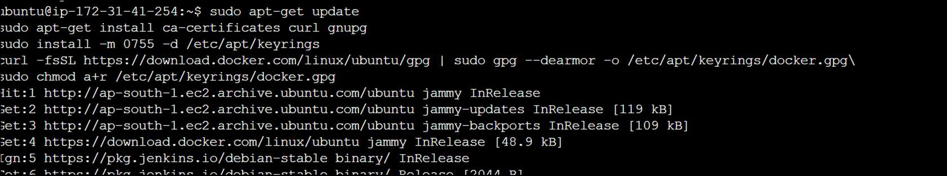
# Add the repository to Apt sources:
echo \
"deb [arch="$(dpkg --print-architecture)" signed-by=/etc/apt/keyrings/docker.gpg] https://download.docker.com/linux/ubuntu \
"$(. /etc/os-release && echo "$VERSION_CODENAME")" stable" | \
sudo tee /etc/apt/sources.list.d/docker.list > /dev/null
sudo apt-get update
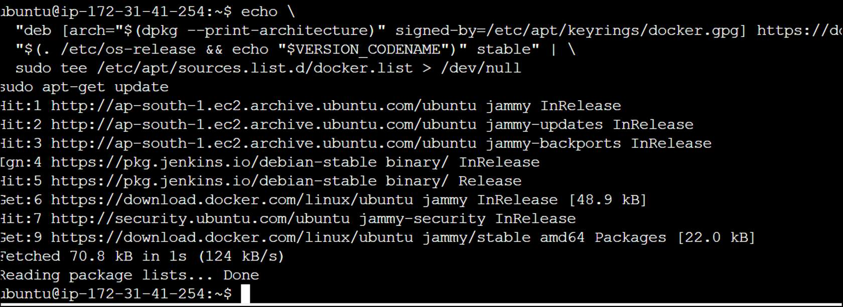
Step 2. Install the Docker packages.
To install the latest version, run:
sudo apt-get install docker-ce docker-ce-cli containerd.io docker-buildx-plugin docker-compose-plugin
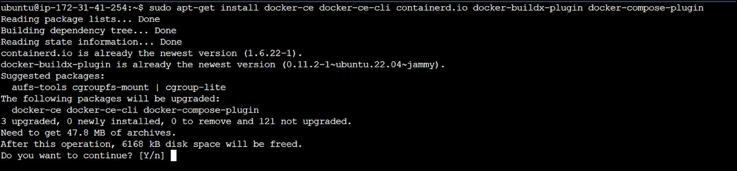
Step 3.Verify that Docker has been installed and is running.
